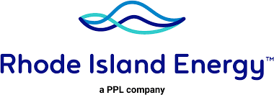
If you need help paying your bills, we have programs and services to make things a little easier. Come and meet with Consumer Advocate from RI ENERGY
Are you sure that you are receiving the right discount on your
electric and gas account? Bring your Medicaid and SNAP card to qualify
for a discount rate, 25% or 30%.
You can meet the Costumer Advocate from RI Energy to review
your accounts and find what payment plan best fit your needs.
Ask for Forgiveness Payment Plan/ Arrears Management Program.
Ask for Infant and Financial Hardship Protection, Elderly and Medical
Protections.

Date: Third Tuesday of each month
Time: 9:00am-1:00pm
Location: BVCAP, 32 Goff Ave., Pawtucket, RI, 02960
Consumer Advocate: Sulman Pino Brand
Consumer Advocate Email: sdpinobrand@rienergy.com
Customer Services Line: 1-855-743-1101

“BRING YOUR MEDICAID AND SNAP CARD TO
ADD A DISCOUNT RATE”

